Lista de ERP

NetSuite ERP
Sage Intacct
Brightpearl ERP
Odoo
ECount ERP
PeopleSoft
Sage 100 ERP
FinancialForce ERP
iXERP Standard
SAP
Microsoft Dynamics Ax Axapta
La gama de ERP´s Oracle
Oracle JD Edwards Enterprise One
Infor LN
Intuit
FIS Global
Fiserv
Corner Corporation
SS&C Techonologies
Constellation Software Inc.

Cuota de mercado ERP 2017

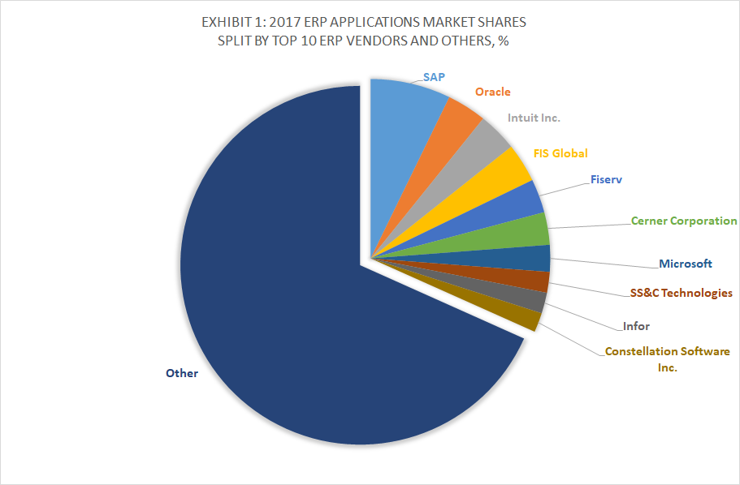
Cuota de mercado CRM 2017
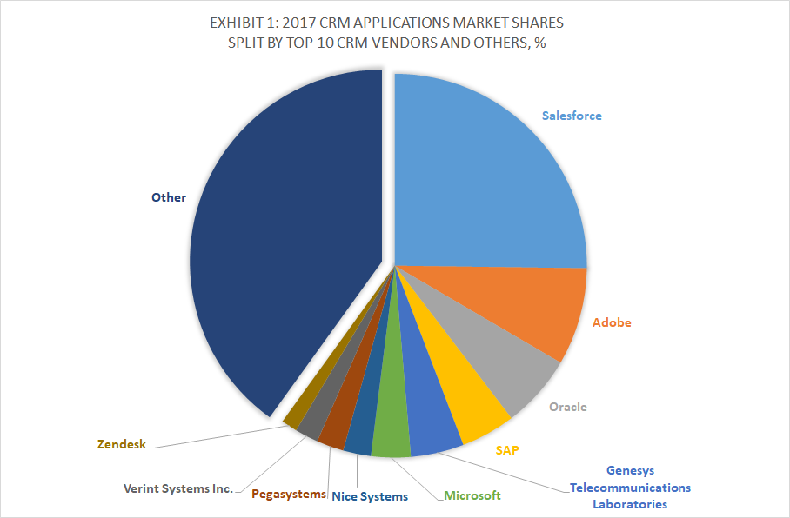
LOS 5 MÁS USADOS
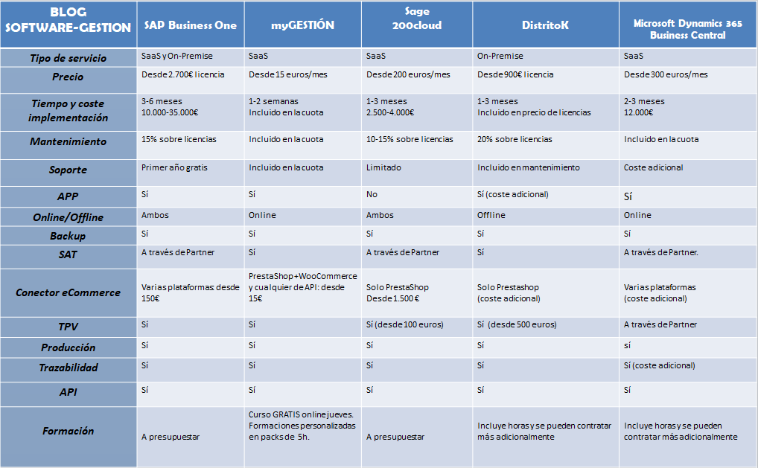
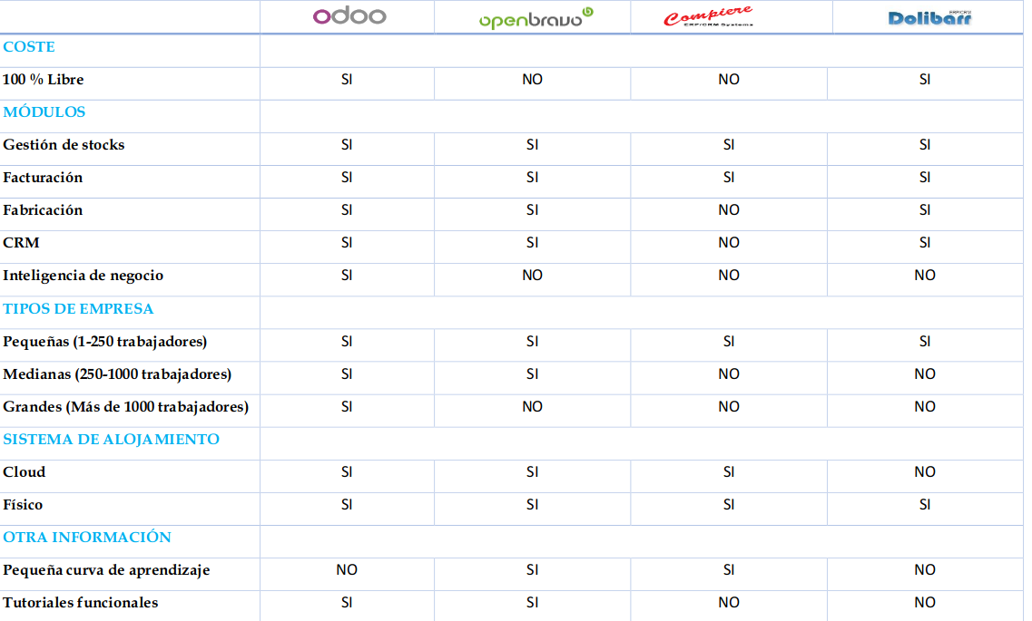
Características Top 4 Free ERP

